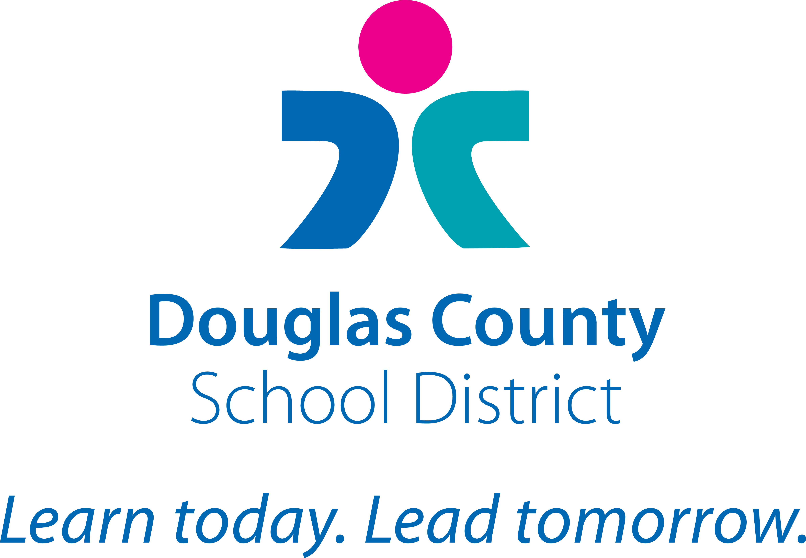
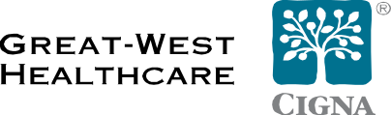

Dear Member:

Welcome to CIGNA Pharmacy, chosen by Douglas County School District and Allegiance Benefit Plan Management, Inc. to manage your prescription drug plan.

In preparation for this upcoming change, please take time to familiarize yourself with your Pharmacy Benefit Plan.

Call Us with Your Questions
For more information about your prescription benefits you may call the dedicated toll-free number 1-800-259-0466.

We look forward to serving you.

Sincerely,

CIGNA

We reference CIGNA and Great-West Healthcare to accommodate all members. CIGNA members, please disregard Great-West Healthcare references.

“CIGNA” and the “Tree of Life” logo are registered service marks of CIGNA Intellectual Property, Inc., licensed for use by CIGNA Corporation and its operating subsidiaries. All products and services are provided exclusively by such operating subsidiaries and not by CIGNA Corporation. Such operating subsidiaries include Connecticut General Life Insurance Company (CGLIC), CIGNA Behavioral Health, Inc., Intracorp, and HMO or service company subsidiaries of CIGNA Health Corporation and CIGNA Dental Health, Inc. In California, HMO plans are offered by Great-West Healthcare of California, Inc. All other medical plans in California are insured or administered by CGLIC. CGLIC has acquired the business of Great-West Healthcare from Great-West Life & Annuity Insurance Company (“GWLA”). Certain products continue to be provided by GWLA (Life, Accident and Disability, and Excess Loss). GWLA is not licensed to do business in New York. In New York, these products are sold by GWLA's subsidiary, First Great-West Life & Annuity Insurance Company, White Plains, N.Y. Rights in all marks are reserved by their respective owners.

